**NETWORKING & SYSTEM ADMINISTRATION LAB**

Name: Sandra Pm

Rollno:34

MCA B

**Experiment No.: 24**

**Aim**

**Steps for installing Docker**

**Procedure**

1. Open the terminal on Ubuntu.

2. Remove any [Docker files](https://www.simplilearn.com/tutorials/docker-tutorial/what-is-dockerfile) that are running in the system

command:

$ sudo apt-get remove docker docker-engine docker.io

After entering the above command, you will need to enter the password of the root and press enter.

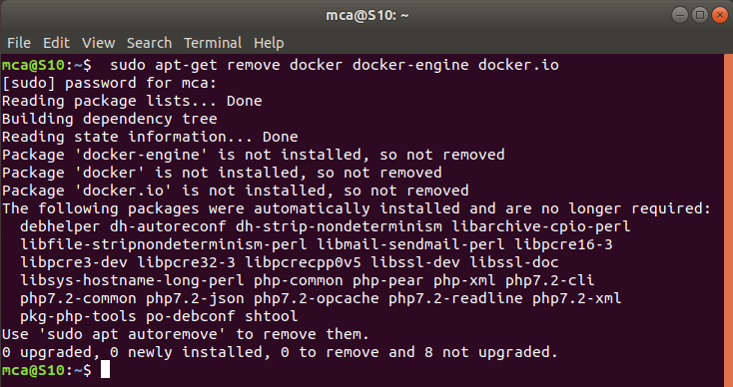

3. Check if the system is up-to-date

command:

$ sudo apt-get update

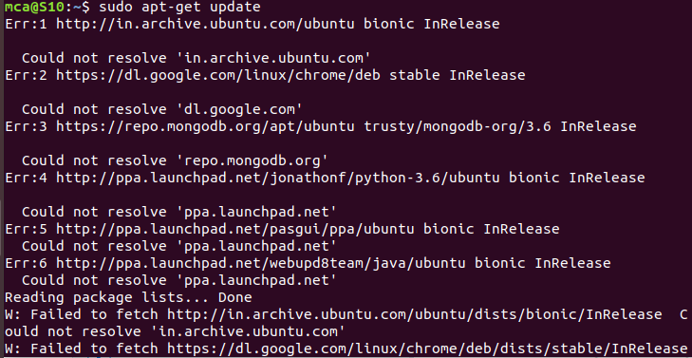

4. Install Docker

command:

$ sudo apt install docker.io

You’ll then get a prompt asking you to choose between y/n - choose y

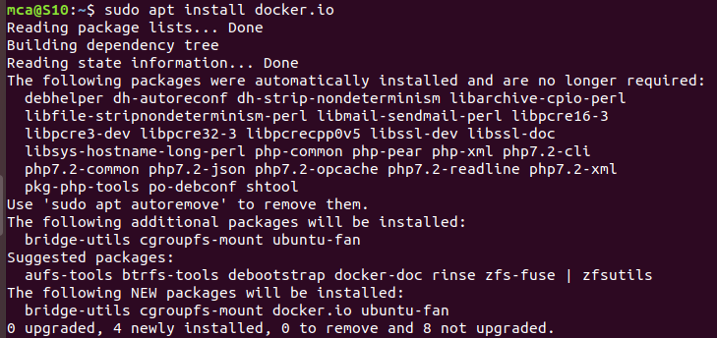

5. Install all the dependency packages

command:

$ sudo snap install docker



6. Before testing Docker, check the version installed

command:

$ docker –version



7. Pull an image from the Docker hub

command:

$ sudo docker run hello-world

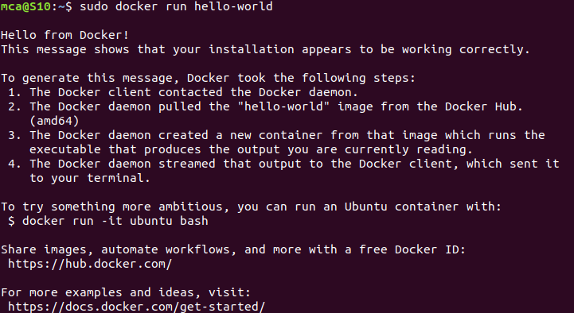

8. Check if the docker image has been pulled and is present in your system

command:

$ sudo docker images

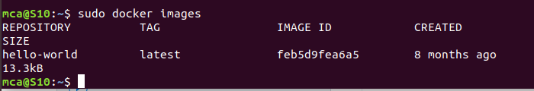

9. To display all the containers pulled

command:

$ sudo docker ps -a

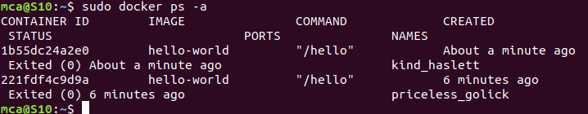

10. To check for containers in a running state

command:

$ sudo docker ps

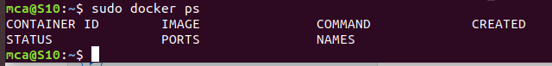

successfully installed Docker on Ubuntu!